SQL CLASS – 3

TOPICS –DML Commands, User and Schema

SQL contains 5 sub languages –

- Data Definition Language (DDL)
- Data Manipulation Language (DML)
- Transactional Control language (TCL)
- Data Query/Retrieval Language (DQL/DRL)
- Data Control Language (DCL)

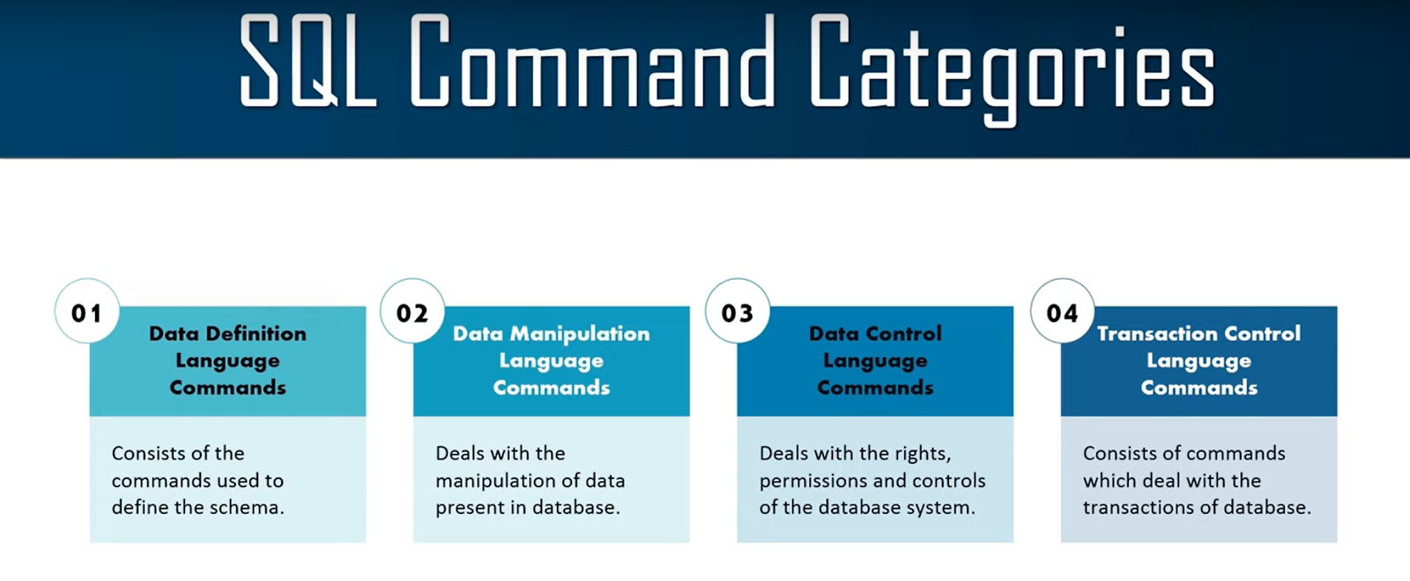

- Data Manipulation Language (DDL) - Insert, Update, Delete

- Data Manipulation Language or DML commands are used for Manipulating data of database like inserting new records or updating existing record or deleting the records.
- All DML commands are not auto-committed which means any changes made will not be permanent in the database.

- Insert - Use to insert new records in database.

Note -
- While inserting the record in the table if column names are not provided then make sure to provide values for all columns in the table with the same order.
- While inserting the record in the table the order of column name and order of column values need to be the same.

Syntax - INSERT INTO studentsInfo (column1, column2, column_n)
VALUES (expr1, expr2, expr_n);

Example -

INSERT INTO studentsInfo
VALUES (1,'Amol','Rao', 9898989898,'Kharadi','Pune','India');

INSERT INTO studentsInfo (StudentId, StudentName, ParentName, PhoneNumber, AddressofStudent)
VALUES (2,'Hari','Prasad', 78787878,'Viman Nagar');

INSERT INTO studentsInfo VALUES (3,'Raj','Sharma', 8785475414,'Thane','Mumbai','India');

INSERT INTO studentsInfo VALUES (4,'Rahul','Mishra', 6545847414,'Civil Lines', 'Mumbai', 'India');

INSERT ALL
INTO studentsInfo (StudentId, StudentName, ParentName, PhoneNumber, AddressofStudent)
VALUES (1,'Amol','Rao', 9898989898,'Kharadi','Pune','India')
INTO studentsInfo (StudentId, StudentName, ParentName, PhoneNumber, AddressofStudent)
VALUES (2,'Hari','Prasad', 78787878,'Viman Nagar')
INTO studentsInfo (StudentId, StudentName, ParentName, PhoneNumber, AddressofStudent)
VALUES (3,'Raj','Sharma', 8785475414,'Thane','Mumbai','India')
SELECT * FROM dual;

- Update - Use to update records present in database

Syntax - UPDATE Table_Name SET Column_Name = new_value;
Example -
UPDATE studentsInfo SET StudentName = 'RAJ';
UPDATE studentsInfo SET StudentName = 'RAJ' WHERE StudentId = 2;

UPDATE studentsInfo SET country = 'USA' WHERE StudentId IN (2,3);

- Delete - Use to delete records from database.

Syntax - DELETE FROM Table_Name;
Example -
DELETE FROM studentsInfo;
DELETE FROM studentsInfo WHERE StudentId = 2;

- Insert All – It is used to add multiple rows with a single INSERT statement. The rows can be inserted into one table or multiple tables using only one SQL command.

Syntax - INSERT ALL
INTO table_1 (column1, column2, column_n)
VALUES (expr1, expr2, expr_n)
INTO table_1 (column1, column2, column_n)
VALUES (expr1, expr2, expr_n)
INTO table_2 (column1, column2, column_n)
VALUES (expr1, expr2, expr_n)
SELECT * FROM dual;

Example -

INSERT ALL
INTO studentsInfo (StudentId, StudentName, ParentName)
VALUES (1, 'Amol', 'Rao')
INTO studentsInfo (StudentId, StudentName, ParentName)
VALUES (2, 'Hari', 'Prasad')
INTO studentsInfo2 (StudentId, StudentName, ParentName)
VALUES (3, 'Raj', 'Sharma')
SELECT * FROM dual;

User and Schema -

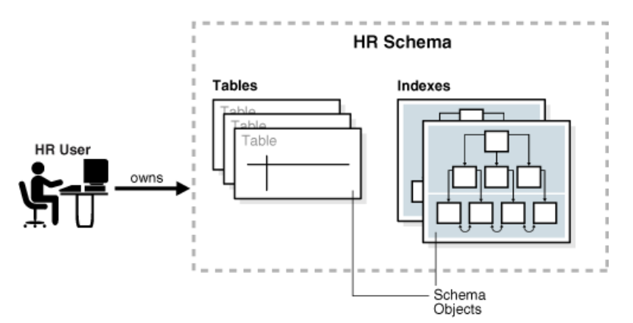
User -
- A database user account has a password and specific database privileges. Each user account owns a single schema, which has the same name as the user.
- The schema contains the data for the user owning the schema.
- For example, the hr user account owns the hr schema, which contains schema objects such as the employees table.

Schema -
- A database schema is a logical container for data structures, called schema objects.
- Examples of schema objects are tables and indexes.

Note - You create users with the create user statement. This also "creates" the schema (initially empty) - you cannot create a schema as such, it is tied to the user. Once the user is created, an administrator can grant privileges to the user, which will enable it to create tables, select queries, insert, and etc.

__________________________THANK YOU____________________________

